**MvTech Network Solutions**

**DPL Network Infrastructure**

**Manoel Vitor Nascimento Lopes**

Student Number - 2019286

College of Computing Technology - CCT College Dublin

ABSTRACT

Dublin Pharmaceutical Limited (DPL) is an expanding medical sales and research company, founded 15 years ago. Due to its recent expansion, DPL is moving to a new location on Dublin's docks.

Depending on the company's needs, MvTech was asked to make a Network Infrastructure plan and service solutions for the company's new expansion.

This project aims to solve the infrastructure problem of this company, I will demonstrate with a practical laboratory using Cisco Packet Tracer and Virtualization to prove the idea that I planned for this case, assuming that I do not have a limit of money to be spent on the project, I will put the best equipment that I think is necessary for this scenario.

According to the company's requirements, only OpenSource programs and solutions will be used in this project. The only equipment that needed to be purchased would be the physical machines for the end-users, servers and network equipment.

ACKNOWLEDGEMENTS

First of all, I would like to thank all the professors at CCT College Dublin, for giving me all the necessary support during my journey, even if it was a short one but it was very valuable, a special thanks to Professor Brendan, for all his teachings related to networks and infrastructure, today I am putting into practice all the knowledge and making sure that I am more confident with the skills that I acquired during this period, I also want to thank my classmates who always motivated me especially to Geovani and Fábio, who became more than classmates, but real friends.

And last but not least a thanks to my family and friends and a more than special thanks to my girlfriend Lissandra Ajzenberg, who have been more than my girlfriend without her support I wouldn't be here today.

To you all, my sincere thanks.

CONTENTS

[Abstract 2](#_Toc48218754)

[Acknowledgements 3](#_Toc48218755)

[Chapter I: Introduction 6](#_Toc48218756)

[OVERVIEW 6](#_Toc48218757)

[GOALS 6](#_Toc48218758)

[SPECIFICATIONS 7](#_Toc48218759)

[WHY IS IT A GOOD PROJECT? 7](#_Toc48218760)

[MAIN GOAL OF THE PROJECT 8](#_Toc48218761)

[THE BEGINNING 9](#_Toc48218762)

[PLANNING 10](#_Toc48218763)

[Chapter II: Literature Review 13](#_Toc48218764)

[FROM WHERE TO START? 14](#_Toc48218765)

[IP ADDRESSES 17](#_Toc48218766)

[DHCP 18](#_Toc48218767)

[VoIP 18](#_Toc48218768)

[DOMAIN CONTROLLER 19](#_Toc48218769)

[FIREWALL 19](#_Toc48218770)

[Chapter III: Implementation 20](#_Toc48218771)

[PACKET TRACER 20](#_Toc48218772)

[MAIN GOAL 20](#_Toc48218773)

[NETWORK INFRASTRUCTURE OVERVIEW 21](#_Toc48218774)

[HIGHLY AVAILABLE AND FAULT TOLERANT NETWORK DESIGN 22](#_Toc48218775)

[SECURE INTER-COMMUNICATIONS WITHIN INTERNAL DIVISIONS 23](#_Toc48218776)

[SEGREGATED WIRELESS LAN SOLUTION FOR GUEST ACCESS 23](#_Toc48218777)

[VOIP SOLUTION 24](#_Toc48218778)

[AUTOMATED IPV4 ADDRESS ALLOCATION 25](#_Toc48218779)

[LOGICAL NETWORK SUBDIVISIONS 25](#_Toc48218780)

[NAME RESOLUTION SERVICES 27](#_Toc48218781)

[SECURE LOCAL AND REMOTE MANAGEMENT OF NETWORKING DEVICES 28](#_Toc48218782)

[VIRTUALIZATION 30](#_Toc48218783)

[Chapter IV: Testing and Evaluation 34](#_Toc48218784)

[NAVIGATING TO INTERNET 34](#_Toc48218785)

[Chapter V: Troubleshooting 39](#_Toc48218786)

[References 41](#_Toc48218787)

CHAPTER I: INTRODUCTION

OVERVIEW

Founded in the 2000s, MvTech has as a priority the quality of services for its customers, we bring the best technologies in the market to our customers, we aim at data security, quality in the installation of the entire network infrastructure, Our expert consultant Manoel Lopes was appointed to meet the needs of Dublin Pharmaceutical Limited (DPL), the project will have a set deadline for completion and may or may not be extended depending on the need of our team to complete the work with the highest possible quality.

Based on the DPL needs, and following the best practice, this project will have as base the Cisco CCNAv7 200-301, wherewith the practical lab I will demonstrate how the company expansion could be based on.

GOALS

* Highly available and fault-tolerant network design.
* Secure inter-communications within internal divisions.
* Communication between partner sites.
* Segregated Wireless LAN solution for guest access.
* VOIP solution.
* Automated IPv4 address allocation.
* Logical network subdivisions.
* Access Control.
* Name resolution services.
* Secure local and remote management of network devices.
* Device Security best practices.

SPECIFICATIONS

In the network part, CISCO equipment will be used, equipment that are out there in the market for years and we have guarantees of their functionality, all the cabling will be redone to better meet our company's specifications and standards, all post-installation support related to configuration, solutions will be provided by our company.

As requested by our client, all technologies to be implemented must be Open Source, as professionalism we recommend the use of machines with the Linux Operating System, for this project I will use Linux Ubuntu and Linux Mint for end users, and Debian and Ubuntu Server.

As an office package, we will recommend the use of Google Suite or LibreOffice, where the company will always have quality tools at hand without having to pay anything for it, with high viability and availability, we will also recommend the use of G-Mail as an email provider, even with the company having its own domain, all management will be configured through G-Mail, thus guaranteeing stability and security in our client's email data.

I have decided to go for Google Services, because G-Mail is free and very easy to configure and we do not have to be worried about faults or missing emails or anything.

WHY IS IT A GOOD PROJECT?

With this project, I have the chance to put all the skills gathered from the course, and put it all together to bring a real-world project to life. It will show the capability of my personal understanding of the concept and technologies that might be used to a real project that I might collaborate in the future.

During the research, I have found so many things that I did not learn during the course that I want to use in this project because it is very exciting to see how those things can be applied in a company. Things such as CCNA, Samba, and more about Sysadmin.

MAIN GOAL OF THE PROJECT

The main goal of this project is to meet all requirements defined in the scenario of the company DPL. Ensure a well-defined infrastructure and application logic, using *opensource[[1]](#footnote-1)* tools and showing that it is possible to meet all requirements with free options.

Free solutions that will be used on this project are:

* Zentyal Server Development Edition
  + 6.1
* Samba
  + 4.3.11
* Webmin
  + 1.954
* Ubuntu Server
  + 14.04
* Debian Server
  + 10.05
* Linux Mint
  + 20.04
* Linux Ubuntu
  + 20.04

**THE BEGINNING**

Well, it is not difficult to imagine how a computer network works today, we live in a world where everyone and almost everything is connected.

Taking our home network as an example, we have one piece of equipment that we call a Router, which in this case is doing the role of receiving connections through different devices and connecting to the internet.

Unlike our home, a company, in this case, DPL needs more resources and equipment that will handle all the demand from users, unlike our homes, a company cannot suffer from network failures.

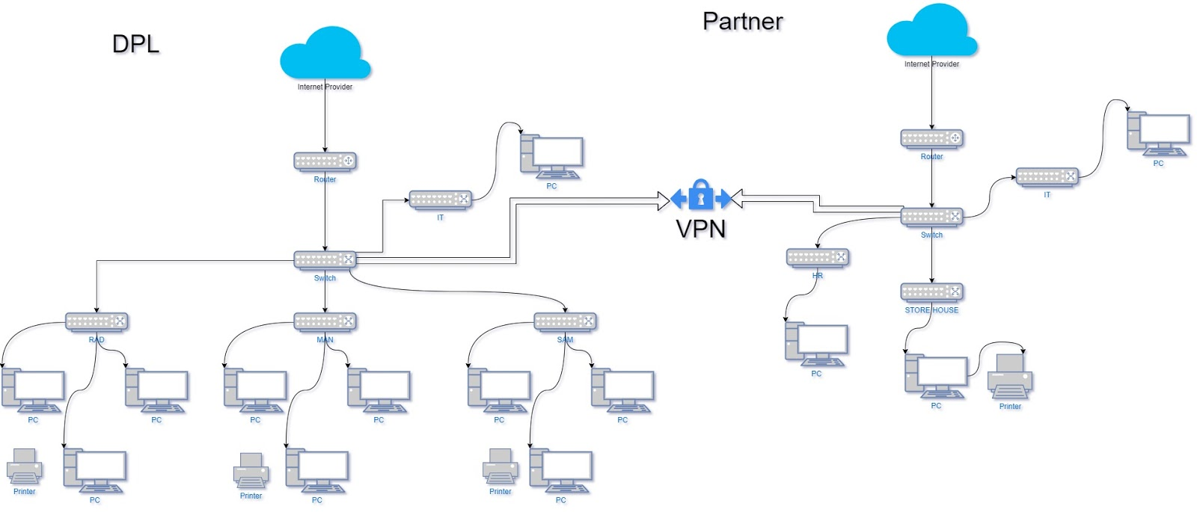Based on this principle, I started my journey with a basic design of how I would implement the DPL network, and this was the first result:

Figure 1 First Design Concept

After having this design in my hands, I started to think about which or which IPs should I use, which network mask, which services and servers, which equipment, which internet providers, which cabling, were many questions that started to haunt me in thinking about how I would solve all of this. Then came the idea of setting my goals and dividing the tasks.

PLANNING

I used two strategies during the project, first I defined a Draft Plan with everything or almost everything that I knew I would need to start and I started working and started adding new tasks during the development of the project using a free solution called *TeamGantt[[2]](#footnote-2).*

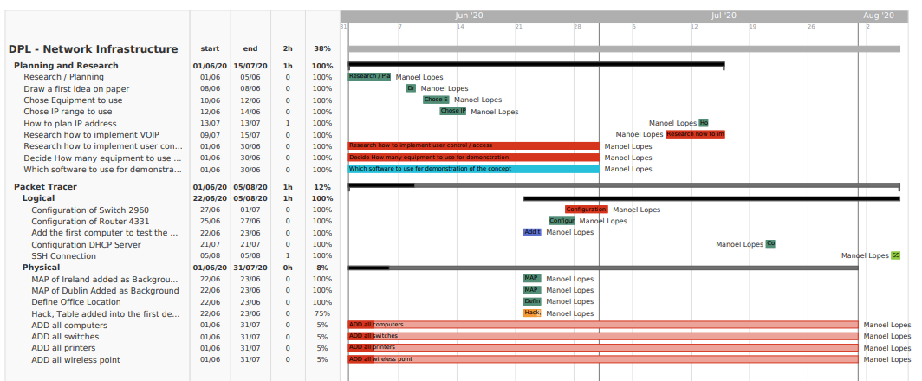I also used *Trello[[3]](#footnote-3)* to help me with the daily tasks that I would perform, separating by three different lists: to do, doing and done. With this technique, I managed to maintain a more organized work pace most of the time.

Figure 2 Gantt Chart

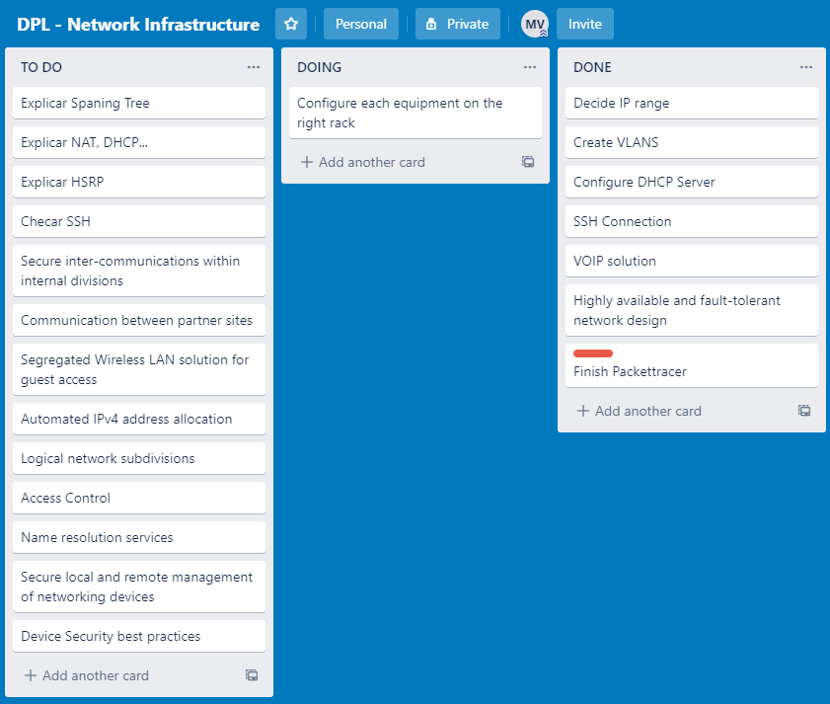

Figure 3 Trello List

With this technique, I managed to maintain a more organized work pace most of the time.

  After deciding to start my project on the packet tracer using my first topology design as a basis, I realized that it did not meet some project requirements such as “Highly available and fault-tolerant network design” it was then that I decided to go back to the drawings and recreate the topology, but this time worrying about meeting all the requirements, and I became with the following result:

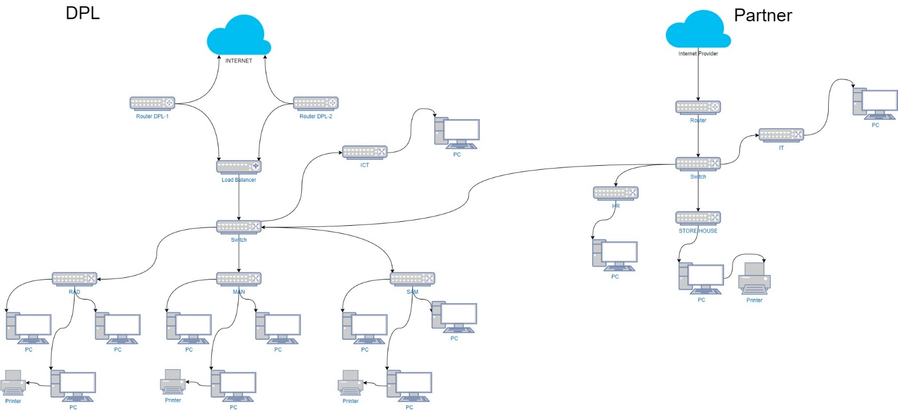

Figure 4 Second Design Concept

The idea behind this image was to use two internet links from different companies, where these links would be linked in a *Loadbalacer[[4]](#footnote-4)* so that if one of the links had any failure the other would assume and so the company would not be without internet, then it would be distributed normally by company departments via switches.

CHAPTER II: LITERATURE REVIEW

This chapter aims to present the academic research carried out throughout the project cycle when I started the project I thought myself it would be an easy chapter to do, but I was wrong when I started my research seeking for knowledge and more information than I had I started to hit into some doubts such as: Which range of IPs should I use? Should I use *VLANS[[5]](#footnote-5)*? And many others, but there are few of them which I think are more relevant and I will describe them in the following pages.

But before the start I decided to go for a new and last design for the project, yes this is the third one, I had changed three times trying to make it as much professional as I could. 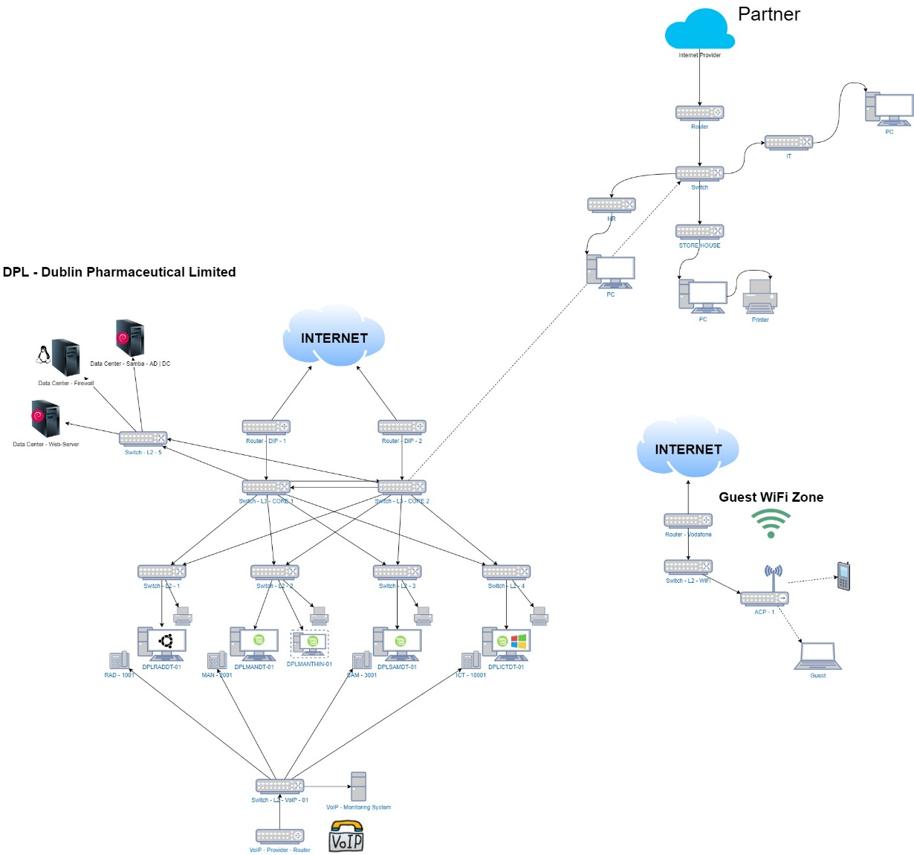

Figure 5 Final Design Concept

FROM WHERE TO START?

I have been questioning myself for few days from where to start a company infrastructure, and after few days and some research and based in few background experiences I had, I think there is no better place to start them thinking in the scalability of the company thinking that the company can grow more and more and we need to be prepared for it, if we do it right from the beginning we do not need to suffer in the future.

I will assume for this scenario that this new field is not prepared to receive more than one thousand employee’s equipment, which means at least 300 computers for research and development department and few for manufacturing and 150 for sales and marketing, not mentioning the laptops, printers, routers, switches and so on.

In this case, as an ICT consultant, I will suggest the company to outsource structured cabling services. Why did I make that decision? After a few days of thinking I realized how essential this part is for a quality project, so let's assume that all structured cabling will be done from scratch by *CET Connect[[6]](#footnote-6)*, an Irish company renowned in the structured cabling market since 1999. We need to think about the future when it comes to infrastructure because the chances of the company growing are great and we can be the next to maintain this network so we will work with the best practices in the market.

Assuming that all cabling was done, now we need to decide which internet companies we will be hiring in this case, we will be hiring two internet links from two different companies, for the simple reason of trying to minimize the risks of connection losses, two links will be hired of 1GBs each with full upstream and downstream, service contracts for any failure in internet equipment must be dealt with within a maximum of 24 hours.

Now we need to decide which equipment we will use for this project, all the equipment related to the network will be *CISCO*[[7]](#footnote-7) equipment that has been on the market for a long time and is already consolidated and we can simulate them on *PacketTracer*[[8]](#footnote-8).

|  |  |  |
| --- | --- | --- |
| Equipment CISCO | Equipment PacketTracer | Quantity |
| Cisco Catalyst 3650 Series SwitchesY:\Production\Cisco Projects\C78 Data Sheet\C78-729449-12\v1a 280616 0342 vinica\C78-729449-12_Cisco Catalyst 3650 Series Switches\Links\C78-729449-12_Figure01.jpg | Switch Layer 3 – 3650 | x2 |
| Cisco Catalyst 2960-X Series Switches  Related image, diagram or screenshot | Switch Layer 2 – 2960 – 48 ports | x30 |
| Cisco Aironet 4800 Access Point  Aironet 4800 | AP-PT | x6 |

Those are the basic equipment we need to set our network we are missing here the routers which will be provided by the internet companies the additional equipment will not be added here because they are not relevant for this chapter.

Now is time to decide which server to use for this company, will be used 2 physical servers one will host the Firewall solution and the other one will host the Active Directory open source solution, in this case, Zentyal will be our domain controller.

|  |  |  |
| --- | --- | --- |
| Equipment DELL | Equipment PacketTracer | Quantity |
| PowerEdge T340 Tower ServerPowerEdge T340 Tower Server | Server – FIREWALL, DHCP, DNS | x1 |
| PowerEdge R7425 Rack Server PowerEdge R7425 Rack Server | Server – Active Directory, Web Server | x1 |

And last but not least the end-user equipment, attending to the company requirements to only use opensource solutions I have decided to design all the company solution based on Linux. Different Linux flavours can be used as the user needs, but as a proof, if this concept I will go for Linux Mint and Ubuntu for the end-users.

The company is segmented in three departments the Research and Development will be using more powerful machines because the job they do request more from their equipment, the Manufacturing will be using one light version of Linux Mint on a *Thin Client*[[9]](#footnote-9), and just a few computers will be provided, having the idea that they might need then just to check few things, such as emails, or check disponibility of some goods on the stock, the Sales and Marketing will be using medium to high-performance equipment, All Servers, Desktop, laptop or Thin client are going to be DELL, dell has a very good support and warrant policy if we run with any issue we can contact them and they might send someone to have a look on the equipment.

|  |  |  |
| --- | --- | --- |
| Equipment DELL | Equipment PacketTracer | Quantity |
| https://i.dell.com/is/image/DellContent/content/dam/global-site-design/product_images/dell_client_products/notebooks/xps_notebooks/xps_15_9500/pdp/notebook_laptop_xps_15_9500_npl_pdp_gallery504x350.jpg?fmt=jpg&wid=570&hei=400XPS 15 Laptop | Laptop - Managers | x4 |
| XPS 8940 DesktopDell-p2419h-monitor  XPS Desktop | PC | x450 |
| Wyse 5040 AIO Thin ClientWyse 5040 | PC | X350 |

IP ADDRESSES

After fill days working on my research about physical infrastructure and equipment, I started to think about the logical things I was about to need on this project, and I decided to go for steps and decided my IP Schema.

I have learned about LANs and Subnets at college and I have heard about VLANs at once, I kept it in mind and started to search about it and decided to go for it, I have divided the departments into different VLANs.

|  |
| --- |
| VLANS-  RAD - Research & Development  Vlan 100 : 192.168.0.0/24  Gateway : 192.168.0.1  Mask - 255.255.255.0  MAN – Manufacturing  Vlan 200 : 192.168.1.0/24  Gateway : 192.168.1.1  Mask - 255.255.255.0  SAM - Sales & Marketing  Vlan 300 : 192.168.2.0/24  Gateway : 192.168.2.1  Mask - 255.255.255.0  DC - Data Centre  Vlan 400 : 10.0.0.0/24  Gateway : 10.0.0.1  Mask - 255.255.255.0  DIP 1 - Dublin Internet Provider  Vlan 500 : 10.55.55.10/24  Gateway : 10.55.55.1  Mask - 255.255.255.0  DIP 2 - Dublin Internet Provider 2  Vlan 500 : 10.55.55.11/24  Gateway : 10.55.55.1  Mask - 255.255.255.0  ICT - Information & communications technology  Vlan 1000 : 192.168.3.0/24  Gateway : 192.168.3.1  Mask - 255.255.255.0 |

Using VLANs if needed I just need to add an another VLAN, and it will keep my network simple and organized.

DHCP

After decided my IP schema I started my research on how to provide those IPs to the clients when I started to search for the DHCP, service which can allocate IPs for network equipment that are requesting. I have configured one *DHCP*[[10]](#footnote-10)serve which will provide an IP address for each PC.

VoIP

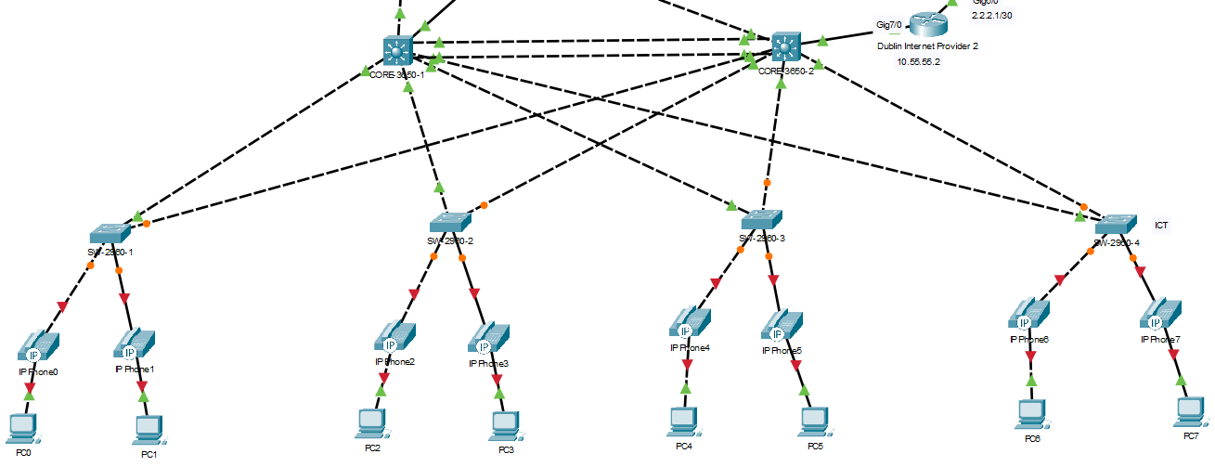VoIP is a short name for Voice over Internet Protocol, which from itself name means voice over the internet, it`s a technology that provides phone calls over the internet protocol. From the begin I had the idea to implement the VoIP on the same network infrastructure, where every department would have its IP Phone attached to the computer this was the idea behind these thoughts:

Figure 6 First idea VoIP

But I could not get it working with the VLANS, I have tried different configurations watched so many videos but did not work. For sure on packet tracer it has been my most difficult challenge.

DOMAIN CONTROLLER

Knowing the requirement of the project is only to use Opensource services, I start my research of any free solution for AD/DC (Active Directory and Domain Controller) that I could use on Linux Server, where I found a video on YouTube showing how to configure a Samba 4 Domain Controller and the guy on the video said so many good things about it and when I went to search more information about it on the internet I realised that most of the topics and videos were about it, so I decided to go for it.

But it was a CAOS, I have tried almost everything, watched hundreds of videos tested with different Linux Distribution but I failed, and just three days before the deadline I found one video of Zentyal Domain Controller, it looked easy to configure, behind the scene Zentyal uses all Samba technology, it is developed on top of Ubuntu Server 18 where the interface is very user friendly and I do not even need to touch the terminal to do anything.

And after a few tests on 43 min of the second half, I decided to set everything on it.

FIREWALL

For me it is the most important research I have done for this project when I started my research on free firewall solutions I found some of them out there, but one day I was watching a guy's video on YouTube and he started talking about Endian Firewall and CISCO certifications that sparked my interest in taking CCNA[[11]](#footnote-11) certifications, I decided to look for more content about CCNA and I came across several preparatory courses on the internet and for sure in the not too distant future I will prepare myself to be taking these certifications.

But in the end I will be using Zentyal built in firewall solution, it is free and open source project as well.

CHAPTER III: IMPLEMENTATION

PACKET TRACER

After spent few days doing researches it comes the time to put all of that together having a look on the company requirements I will separate this chapter in two parts the first one is the packet tracer schema, and the second one will be the virtualization where I will explain how the servers and the clients will behave in the scenario.

MAIN GOAL

Attend to all company requirements:

* Highly available and fault tolerant network design

100%

* Secure inter-communications within internal divisions

100%

* Communication between partner sites

100%

* Segregated Wireless LAN solution for guest access

100%

* VOIP solution

50%%

* Automated IPv4 address allocation

100%

* Logical network subdivisions

100%

* Access Control

100%

* Name resolution services

100%

* Secure local and remote management of networking devices

100%

* Device Security best practices

100%

NETWORK INFRASTRUCTURE OVERVIEW

Departments

* RAD (Research and Development)
  + 300 Employees
* MAN (Manufacturing)
  + 550 Employees
* SAM (Sales and Marketing)
  + 150 Employees
  + 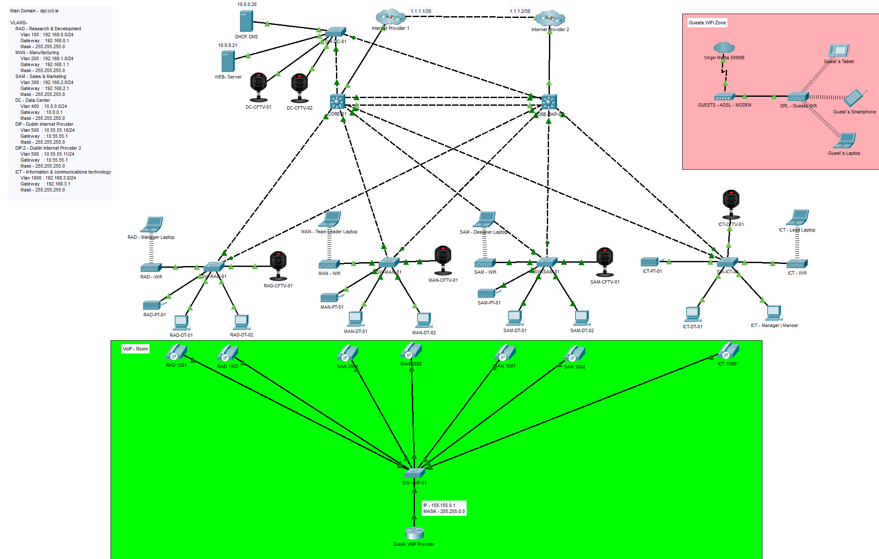ICT (Information and communications technology)  
    10 Employees

Figure 7 Final topology

HIGHLY AVAILABLE AND FAULT TOLERANT NETWORK DESIGN

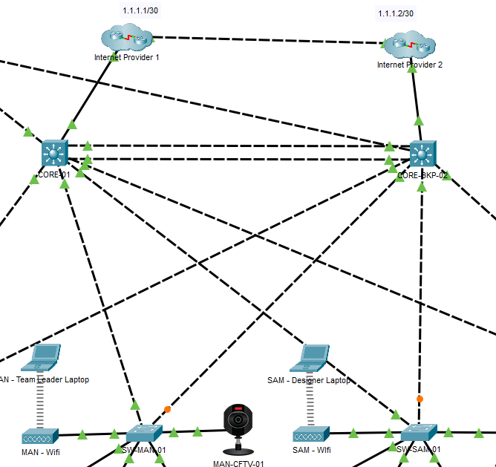As described before I will suggest two internet links from two different providers, which I will refer on this project to DIP-1[[12]](#footnote-12) and DIP-2, I have added 2 routers to represent those two internet providers and I have connected each one to a Switch Layer 3 and connected those two Switches Layer 3 making a port channel it is simple to make 2 different interfaces in one, and from there every single Switch Layer 2 that will cascade the entire network will be connected to those Switches Layer 3 with this idea I have the redundancy in case of one of the internet providers go down the other one will assume and if for any reason one of the Switches Layer 3 fails the other one will assume as well.

Figure 8 Redundancy internet link

SECURE INTER-COMMUNICATIONS WITHIN INTERNAL DIVISIONS

The Requirement of this topic was that DPL R&D division require an intranet site accessible only to that division and the partner company.

I have created an ACL[[13]](#footnote-13) to block the others department to have access to this intranet, it had been set on CORE-1 Switch Layer 3.

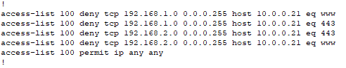

Figure 9 ACL List

SEGREGATED WIRELESS LAN SOLUTION FOR GUEST ACCESS

For this project I will suggest to DPL to go for one Internet Link of 500 MB from Virgin Media, for example, it could be any other company, just to make sure that the Guest users won’t have any access to the company network, it will be a completely separated network.

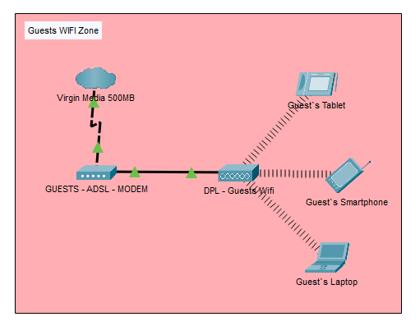

Figure 10 Guests Wi-Fi Topology

VOIP SOLUTION

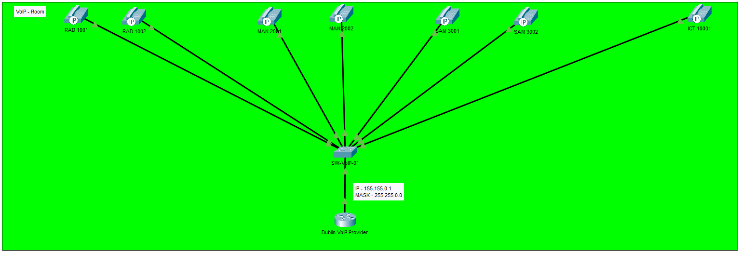It has been very frustrating to me that I was not able to make it work on the same switches and routers, the initial idea was to make everything together but I struggle with it for many days, watched so many videos and tried many things I gave up and adopted another idea to make it a completely separated network, with its equipment.

Figure 11 VOIP Network

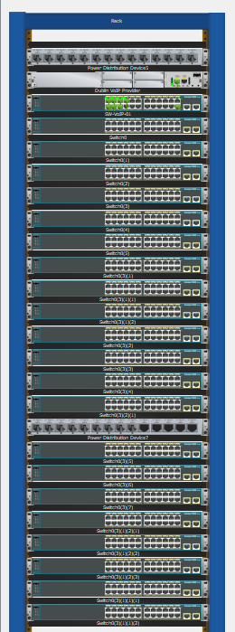

Figure 12 VOIP Switches Available

AUTOMATED IPV4 ADDRESS ALLOCATION

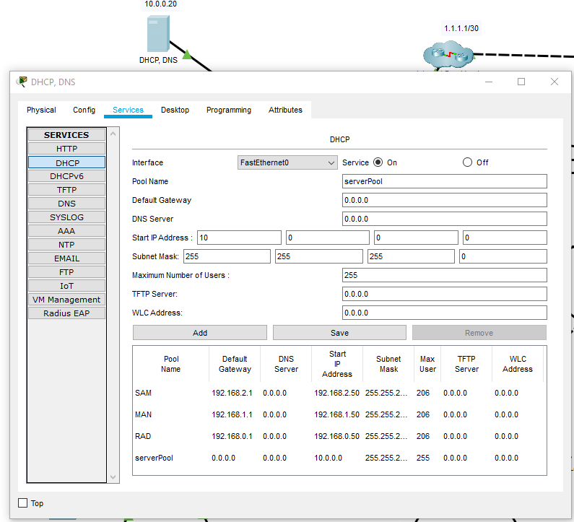DHCP Server implemented to generate IPv4 address according to the network, for example if one computer with gateway 192.168.1.0 request an IP address the DHCP Server will provide one IP from the Range 192.168.1.50 to 192.168.1.250. Three different pools have been added for each VLAN.

Figure 13 DHCP Server

LOGICAL NETWORK SUBDIVISIONS

I decided to divide the network into VLANs, in case of one person from RAD needs to work in the SAM department it will be easy to move the RAD VLAN to the SAM Switch and it will have the internet as normally.

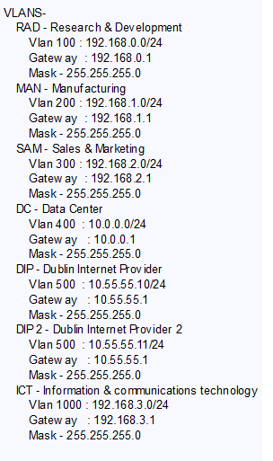

Figure 14 VLANs Schema

NAME RESOLUTION SERVICES

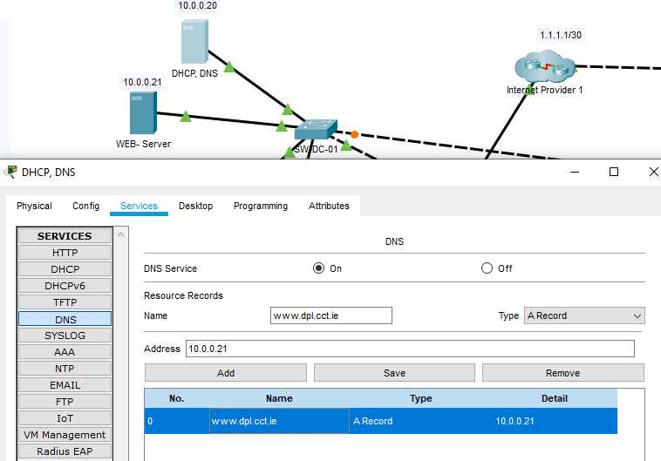The DNS[[14]](#footnote-14) Service is up and running, it is redirecting the request from the name [www.dpl.cct.ie](http://www.dpl.cct.ie) to the Web Server 10.0.0.21 which is located into another machine.

Figure 15 DNS Server

SECURE LOCAL AND REMOTE MANAGEMENT OF NETWORKING DEVICES

To ensure the security of the equipment the local login is activated, and user name and password are requested to login, for the remote management *SSH*[[15]](#footnote-15) is necessary to log in as well.

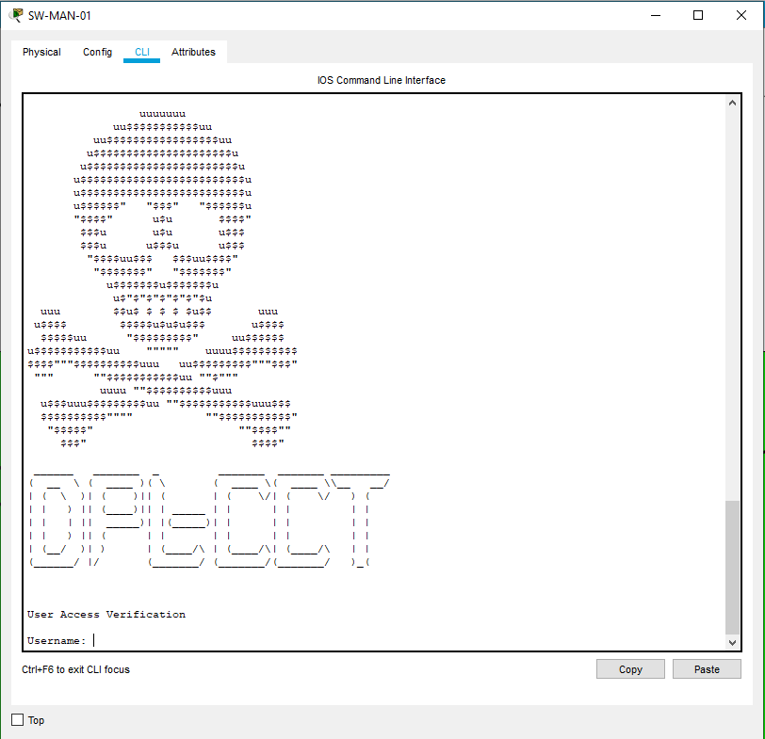

Figure 16 Local Login

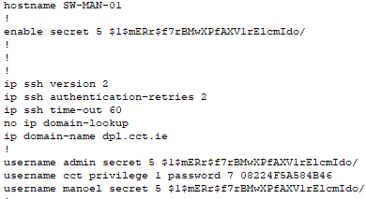

Figure 17 Running config

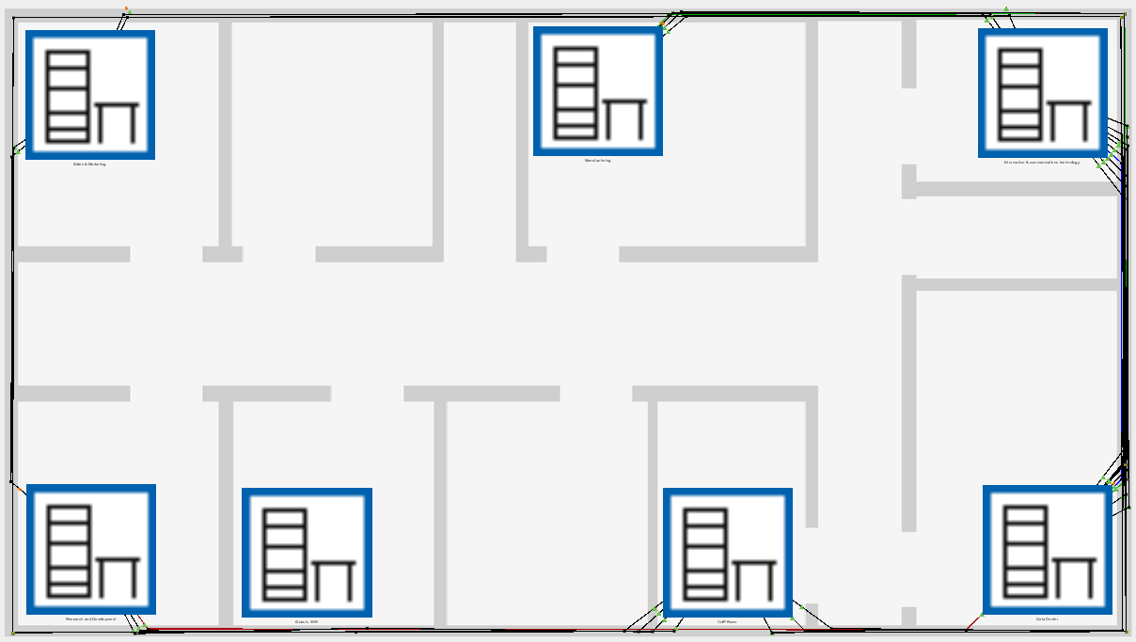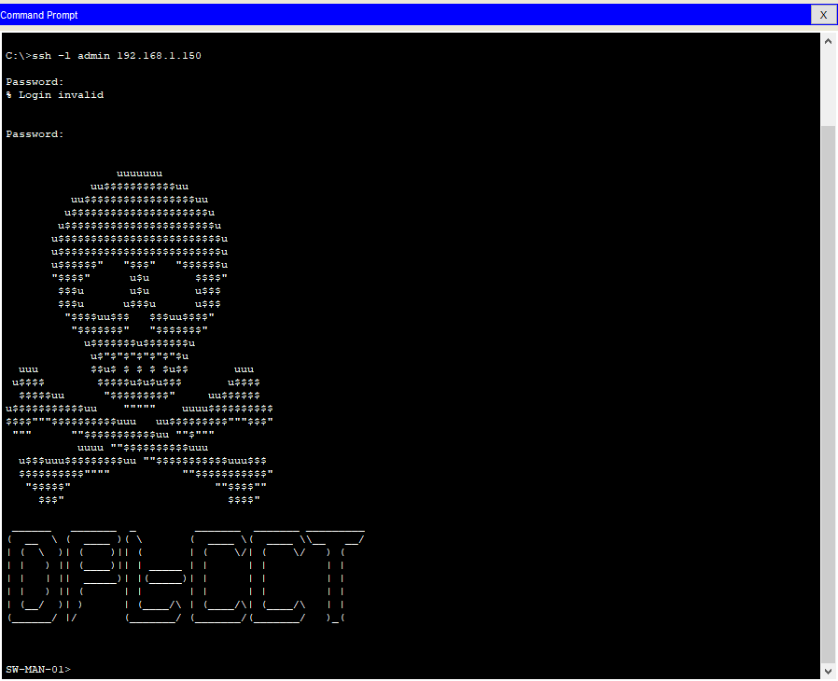

Figure 18 Physical Topology

Figure 19 SSH Login

VIRTUALIZATION

For this topic, as requested from DPL all the solutions I will describe are 100% FREE for the firewall as we have bought one powerful server just to host the firewall and DHCP Server I have implemented Endian Firewall Community Edition a free firewall very easy to install and to manage. For the Domain Controller I have choice Ubuntu Server for the Operating System and the Samba 4 Solution, and for the clients all machines with Linux Mint, Ubuntu e just to show how powerful samba is one machine with Windows 7 to manage the Active Directory from the Windows Administrator Tools, and to Manage the Active Directory from Linux Machines I used Webmin an online application that allow us to manage our AD.

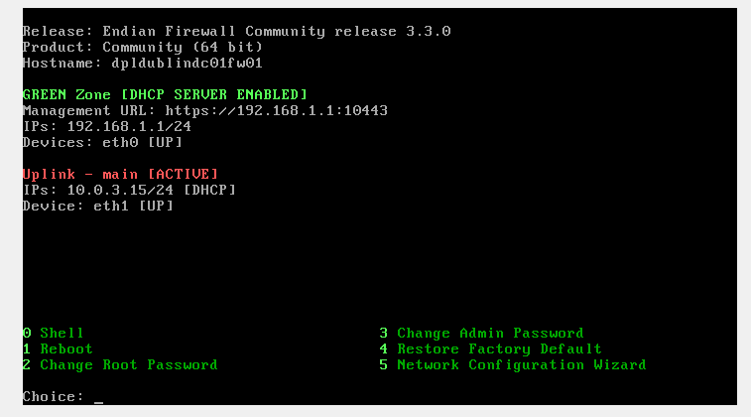

Figure 20 Endian Firewall Community Edition

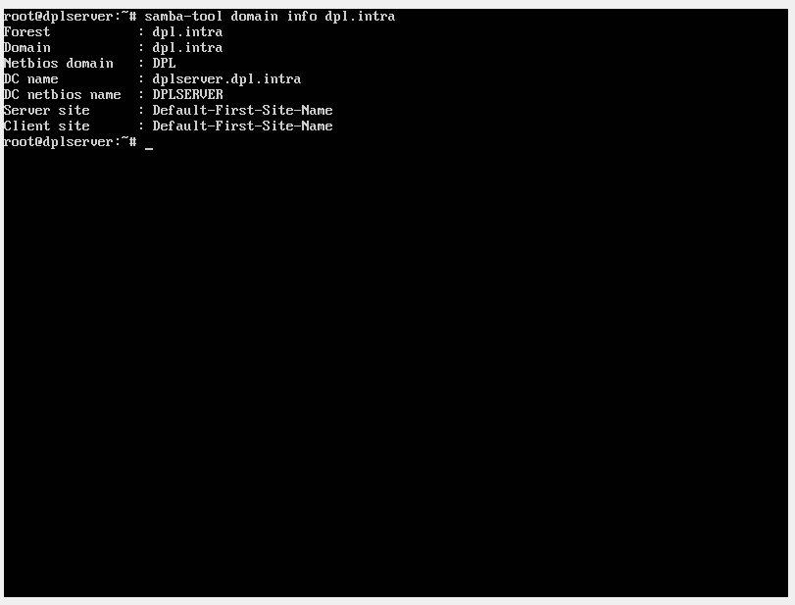

Figure 21 Samba Server

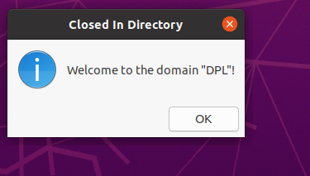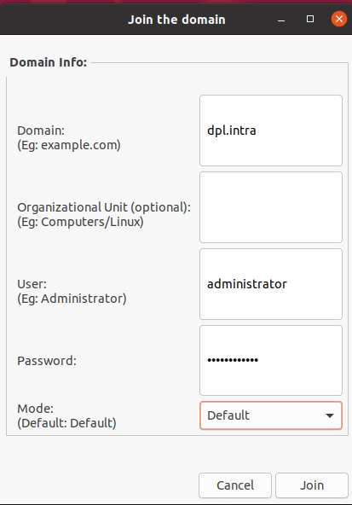

Figure 22 Joined to Domain

Figure 23 Joining the Domain

Everything was looking fine to me, I had tested but sometimes I was getting trouble with my domain and DNS and the firewall and I could not log in to different accounts or sometimes I could not even login with the Administrator user anymore, so I decided that was time to find a solution and I changed everything to Zentyal Server.

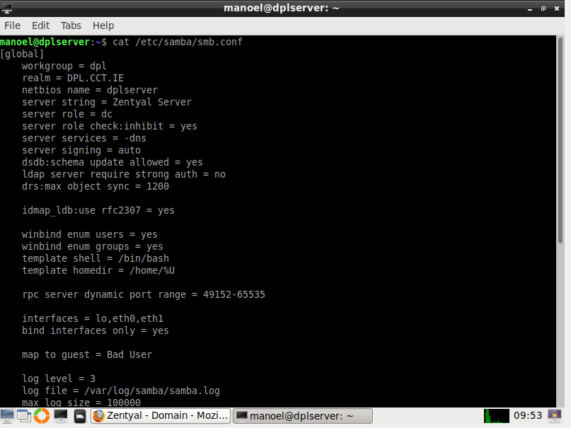And it is how it looks like now:

Figure 24 Zentyal Server

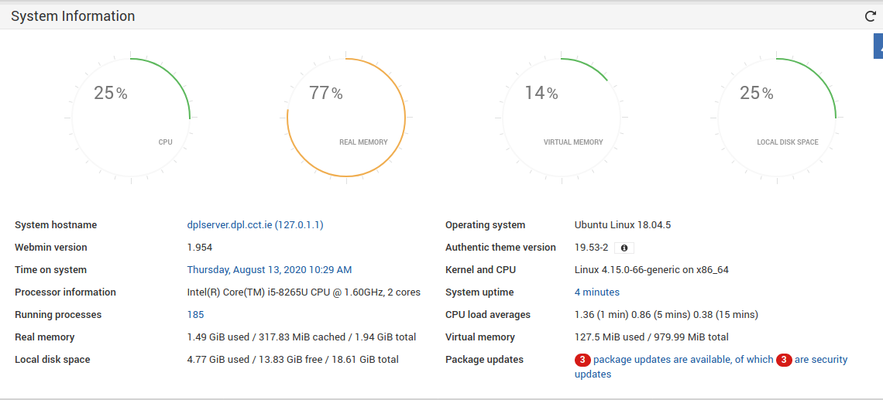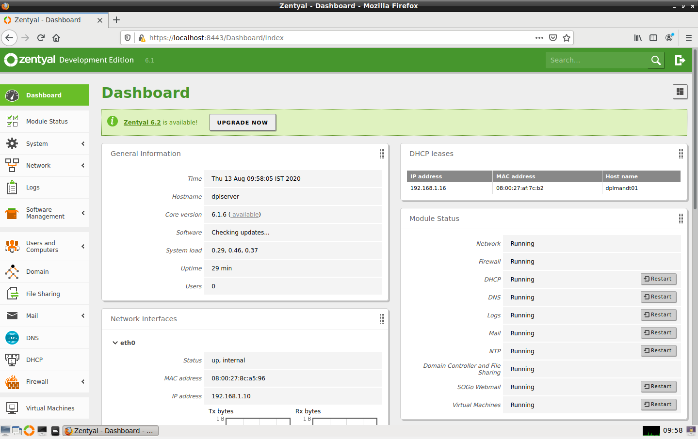

Figure 25 Webmin Dashboard

Figure 26 Zentyal Dashboard

CHAPTER IV: TESTING AND EVALUATION

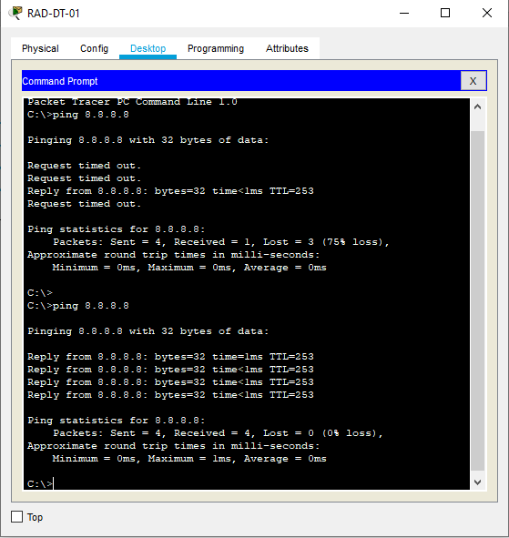NAVIGATING TO INTERNET

Figure 27 Pinging Google DNS 8.8.8.8

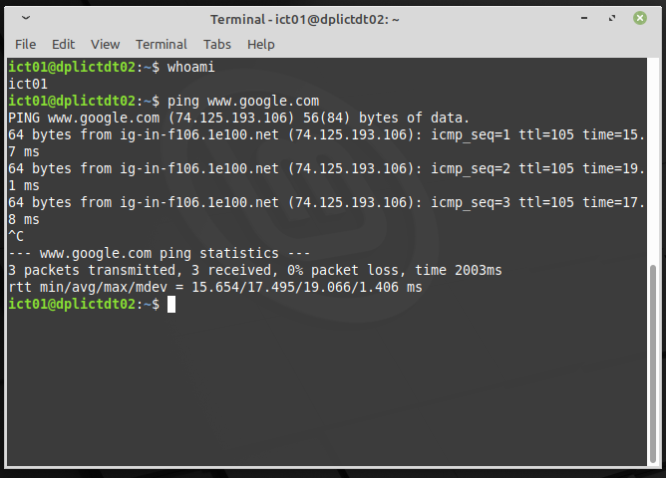

Figure 28 Pinging Google from end-user machine

|  |  |  |  |
| --- | --- | --- | --- |
| TEST NAME | EXPECTING | RESULT | OBSERVATIOS |
| Ping | The machines are able to navigate on the internet. | Pass | Simple test to see if the machines are able to navigate |

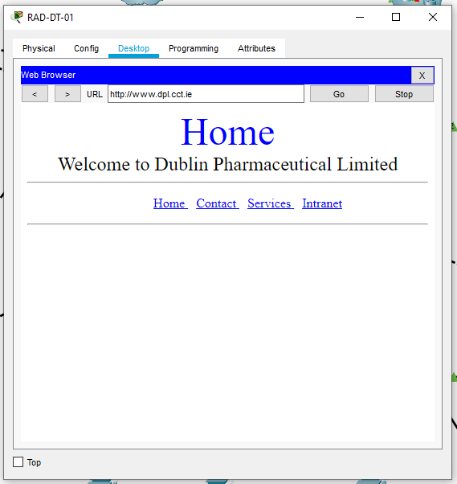

Figure 29 R&D accessing intranet

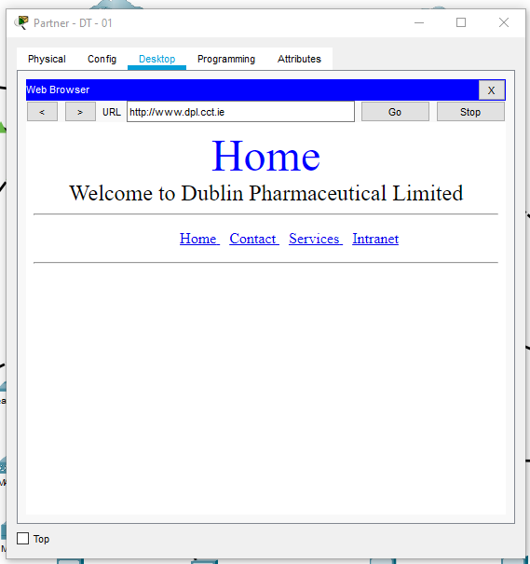

Figure 30 Partner machine accessing the intranet

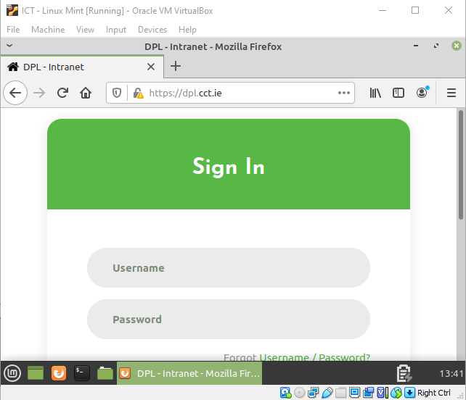

Figure 31 End-User Accessing Intranet

|  |  |  |  |
| --- | --- | --- | --- |
| TEST NAME | EXPECTING | RESULT | OBSERVATIOS |
| Intranet | The machines are able to navigate on the intranet. | Pass | Testing if the requirement of intranet for R&D and Partner is ok. |

Figure 32 Intranet not available for other network

|  |  |  |  |
| --- | --- | --- | --- |
| TEST NAME | EXPECTING | RESULT | OBSERVATIOS |
| Intranet blocking users from other networks | The machines are not able to access the intranet, it is only for partner and R&D department | Pass | Testing if the requirement of intranet for R&D and Partner is ok. |

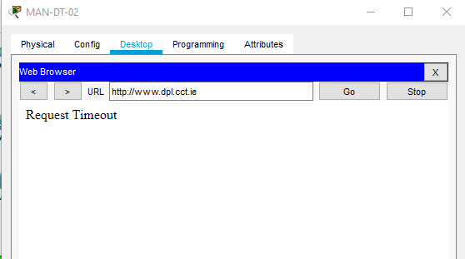

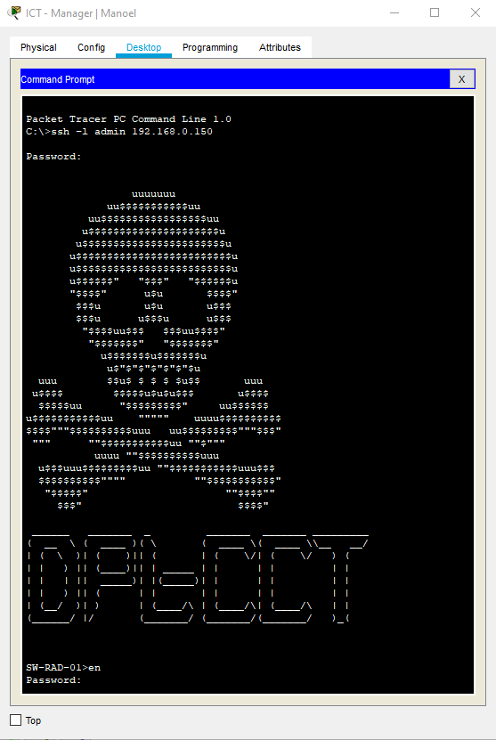

Figure 33 SSH Connection

|  |  |  |  |
| --- | --- | --- | --- |
| TEST NAME | EXPECTING | RESULT | OBSERVATIOS |
| SSH | Network equipment are able to be managed by using SSH | Pass | SSH used to manage the network equipment |

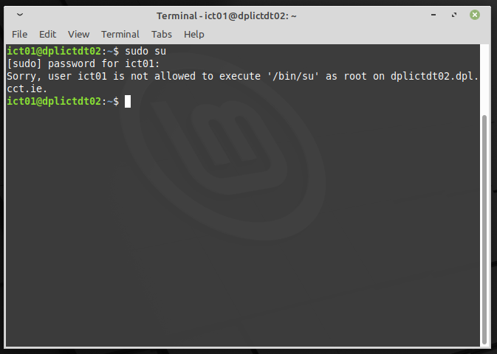

Figure 34 Users are blocked by GLPI

|  |  |  |  |
| --- | --- | --- | --- |
| TEST NAME | EXPECTING | RESULT | OBSERVATIOS |
| User Rights | Users are managed by what are they allowed to do from the admin. | Pass |  |

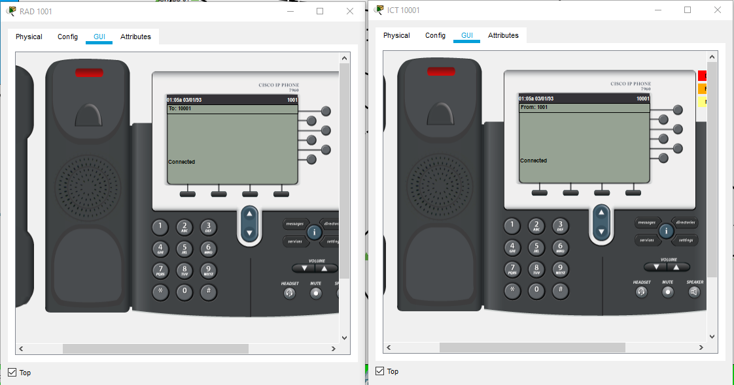

Figure 35 Testing VOIP

|  |  |  |  |
| --- | --- | --- | --- |
| TEST NAME | EXPECTING | RESULT | OBSERVATIOS |
| VOIP | Able to call another department using VOIP. | Pass |  |

CHAPTER V: TROUBLESHOOTING

In this chapter I will report the biggest issues I encountered on my way, few of then left me stuck for several days, unfortunately, I was not able to make VOIP work within the same network, thus having to create VOIP on a separated network. Another problem that made me break my head for several days was Samba, I was in no way able to make it work on my network, they were some challenges and here I will report how I managed to resolve and continue with the project.

VOIP

The first idea was to make the VOIP service work with the same infrastructure designed for the entire network, I have tried so many things, read tons of content on the internet tried everything that I found and it did not work.

At the end after been tired of not get it working I have the idea to make it from the beginning again in a different network with a new Router, Switches and IP Phones and it works, it might not be the best idea for a real project but was something I was struggling with and I found a way to turn around and get the requirement done.

SAMBA DOMAIN CONTROLLER

On my first try samba just worked fine, I thought it had been so easy to set but when I turned my computer off and on again, everything just stopped to work, my end-user machines were not able to connect into the Domain any more, it was the time when I started to fill the pressure of the time to get this project done.

I spent almost my entire month working on it, I have tried almost every single version of Linux Ubuntu, Debian, Suse and others to make it work, but I could not.

And just few days before the dead line I found the solution with another Open Source project called Zentyal, it uses Samba behind the scene but makes the installation process very simple and intuitive.

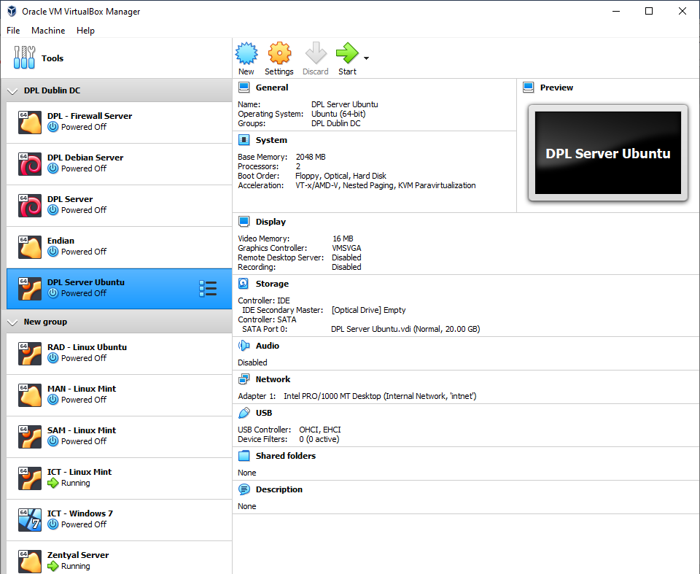

Figure 36 Few Virtual Machines of my trial

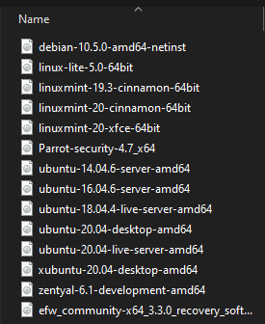

Figure 37 Few Linux images

CHAPTER VI: CONCLUSION

Reading Rainbow Tip: It’s important to give your opinion! Would you recommend this book to someone else?

REFERENCES

Azam, W. (2019, May 21). w7cloud. Retrieved 2020, from Configuration of SSH on Cisco Switch in Packet Tracer 2019: <https://w7cloud.com/configuration-of-ssh-on-cisco-switch/>

Opensource, Com. (2020, August 11). opensource.com. Retrieved 2020, from What is open source?: <https://opensource.com/resources/what-open-source>

Practical Networking. (2019, November 10). YouTube. Retrieved 2020, from What are VLANs? -- the simplest explanation: <https://www.youtube.com/watch?v=MmwF1oHOvmg>

Kerravala, Z. (2018, August 21). networkworld. Retrieved 2020, from DHCP defined and how it works: <https://www.networkworld.com/article/3299438/dhcp-defined-and-how-it-works.html>

3cx. (2020, August 12). 3cx. Retrieved 2020, from VoIP Definition: <https://www.3cx.com/pbx/voip-definition/>

Ramos. J. (2020, June 20). YouTube. Retrieved 2020, from Samba4 como controlador de Domínio: <https://www.youtube.com/watch?v=E_GGg7Brx8Q>

Kimanzi, S. (2018, July 5). computernetworking. Retrieved 2020, from Secure Shell (SSH) configuration on a switch and router in Packet Tracer: <https://computernetworking747640215.wordpress.com/2018/07/05/secure-shell-ssh-configuration-on-a-switch-and-router-in-packet-tracer/>

Bora para prática. (2016, July 18). YouTube. Retrieved 2020, from Instalação do UTM Endian Firewall v3.2 no VirtualBOX SAMBA 4 Level 2 - 12/17: <https://youtu.be/TQQXFew9B_M?list=PLozhsZB1lLUNy36DZzeuR0VqcQyqOWTpw>

Student. (2018, August 01). Website for Students. Retrieved 2020, from Install WordPress on Ubuntu 16.04 LTS with Apache2, MariaDB and PHP 7.1 Support: <https://websiteforstudents.com/install-wordpress-on-ubuntu-16-04-lts-with-apache2-mariadb-and-php-7-1-support/>

Zentyal. (2020). Zentyal Community. Retrieved 2020, from Zentyal 6.2 Official Documentation: <https://doc.zentyal.org/en/index.html>

Kalu. G. (2020, July 23). YouTube. Retrieved 2020, from Curso de Redes de Computadores Básico Mão na Massa: <https://www.youtube.com/watch?v=5pFJPVg5nbE&list=PL6BTdBqzl1oY9EQ4151rGNEbATMNgX8vK>

1. Opensource software that uses an open development process and is licensed to include the source code.

   Opensource, Com. (2020, August 11). opensource.com. Retrieved 2020, from What is open source ?: https://opensource.com/resources/what-open-source [↑](#footnote-ref-1)
2. TeamGantt is a simple and free project management tool designed to help you create, manage, and finish your projects on time. [↑](#footnote-ref-2)
3. Trello Trello is a web-based Kanban-style list-making application. [↑](#footnote-ref-3)
4. load balancer device is a physical appliance used to manage two or more internet links. [↑](#footnote-ref-4)
5. VLANs (Virtual LANs) are logical grouping of devices in the same broadcast domain.

   Study-ccna, Com. (2020, August 11). study-ccna.com. Retrieved 2020, from What is a VLAN? : https://study-ccna.com/what-is-a-vlan/ [↑](#footnote-ref-5)
6. CET Connect https://cet.ie/ [↑](#footnote-ref-6)
7. Cisco is the worldwide leader in IT, networking, and cybersecurity solutions. [↑](#footnote-ref-7)
8. PacketTracer free software where we can simulate a network using CISCO equipment. [↑](#footnote-ref-8)
9. Thin Client simple (low-performance) computer that has been optimized for establishing a remote connection with a server. [↑](#footnote-ref-9)
10. DHCP is a network server that automatically provides and assigns IP addresses, default gateways and other network parameters to client devices. [↑](#footnote-ref-10)
11. Cisco Certified Network Associate Routing & Switching (CCNA), validates your ability to install, configure and maintain small to medium size network infrastructure. [↑](#footnote-ref-11)
12. DIP – Short name for Dublin Internet Provider [↑](#footnote-ref-12)
13. Access Control List controls the traffic that are passing in that switch. [↑](#footnote-ref-13)
14. Domain Name Service (DNS) is used to convert the website name for example [www.cct.ie](http://www.cct.ie) into the IP address of the server where the website is located to. [↑](#footnote-ref-14)
15. Secure Shell (SSH) is a protocol that allow users to connect to network devices with safety. [↑](#footnote-ref-15)